**Experiment -1**

**Aim-** To explore the basic features of TensorFlow and Keras packages in Python. Write the installation steps of TensorFlow.

**Theory-**

TensorFlow is a popular framework of machine learning and deep learning. It is a free and open-source library which is released on 9 November 2015 and developed by Google Brain Team. It is entirely based on Python programming language and use for numerical computation and data flow, which makes machine learning faster and easier. TensorFlow can train and run the deep neural networks for image recognition, handwritten digit classification, recurrent neural network, word embedding, natural language processing, video detection, and many more. TensorFlow is run on multiple CPUs or GPUs and also mobile operating systems.

* **Tensor** is a multidimensional array
* **Flow** is used to define the flow of data in operation.

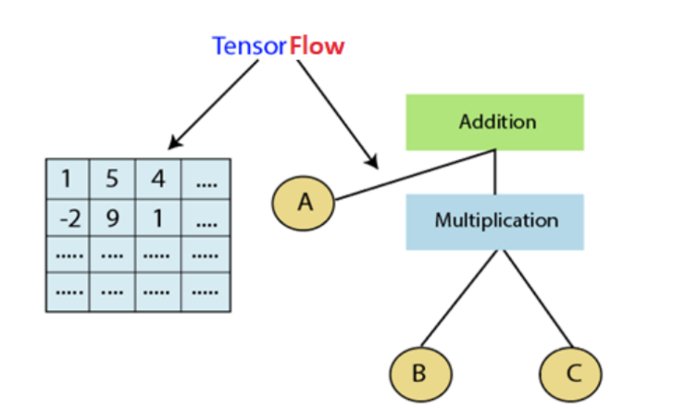

Features of TensorFlow −

* It includes a feature that defines, optimizes and calculates mathematical expressions
* easily with the help of multi-dimensional arrays called tensors.
* It includes programming support of deep neural networks and machine learning
* techniques.
* It includes a highly scalable feature of computation with various data sets.
* TensorFlow uses GPU computing, automating management. It also includes a unique
* feature of optimization of the same memory and the data used.

TensorFlow is the library for all because it is accessible to everyone. TensorFlow library integrates different API to create a scale deep learning architecture like CNN (Convolutional Neural Network) or RNN (Recurrent Neural Network). TensorFlow is based on graph computation. It can allow the developer to create the construction of the neural network with Tensorboard. This tool helps debug our program. It runs on CPU (Central Processing Unit) and GPU (Graphical Processing Unit).

**Key Concepts:**

1. **TensorFlow and Keras**: TensorFlow is the backend that handles the computations, while Keras is the high-level API that simplifies building models.
2. **Neural Networks**: A neural network is a series of layers that process input data to produce an output. Each layer contains nodes (neurons) that apply transformations to the data.
3. **Activation Functions**: These functions introduce non-linearity into the model, allowing it to learn complex patterns. Common activation functions include ReLU (Rectified Linear Unit) and softmax.
4. **Loss Function**: This measures the difference between the predicted output and the actual output. During training, the goal is to minimize the loss.
5. **Optimizer**: The optimizer updates the weights of the network to minimize the loss. Common optimizers include SGD (Stochastic Gradient Descent) and Adam.

**Applications-**

1. **Image Recognition and Computer Vision**: TensorFlow powers image recognition systems, enabling applications like object detection, facial recognition, and image classification. It's widely used in security systems, social media, and autonomous vehicles, where identifying and analyzing images is crucial.
2. **Natural Language Processing (NLP)**: TensorFlow is used to build NLP models that understand and process human language. Applications include sentiment analysis, machine translation, and chatbots, making it essential in improving communication between humans and machines.
3. **Speech Recognition**: TensorFlow enables the development of speech recognition systems, allowing applications like virtual assistants (e.g., Google Assistant, Siri) and automated transcription services to convert spoken language into text, enhancing user interaction with devices.
4. **Time Series Forecasting**: TensorFlow is applied in time series forecasting, where it analyzes historical data to predict future trends. This is useful in finance for stock market prediction, in meteorology for weather forecasting, and in various industries for demand prediction.
5. **Healthcare and Medical Diagnosis**: TensorFlow assists in the healthcare industry by analyzing medical images and patient data to aid in diagnosis and treatment planning. It's used in applications like cancer detection, predictive analytics, and personalized medicine, improving patient outcomes.
6. **Recommender Systems**: TensorFlow is the backbone of recommendation engines used by e-commerce platforms and streaming services. These systems analyze user behavior and preferences to suggest products, movies, or music, enhancing the user experience by delivering personalized content.
7. **Robotics and Autonomous Systems**: In robotics, TensorFlow is used to develop intelligent systems that can navigate, perceive their environment, and make decisions autonomously. This is critical in applications like self-driving cars and industrial automation, where precision and safety are paramount.
8. **Generative Models**: TensorFlow supports generative models that create new content, such as art, music, or text. These models are used in creative industries to generate realistic images, compose music, or even write stories, pushing the boundaries of AI in creativity.
9. **Finance and Fraud Detection**: In the finance sector, TensorFlow is utilized for risk assessment, fraud detection, and credit scoring. By analyzing transaction patterns and financial data, it helps in identifying fraudulent activities and making informed financial decisions.
10. **Anomaly Detection**: TensorFlow's anomaly detection capabilities are employed in various industries to monitor and identify unusual patterns that could indicate issues, such as equipment failure in manufacturing or security breaches in cybersecurity, ensuring operational integrity and safety.

**Features-**

1. **Flexibility in Model Building**: Supports both high-level (Keras) and low-level APIs for model development.
2. **Cross-Platform Deployment**: Models can be deployed on CPUs, GPUs, TPUs, mobile devices, and web browsers.
3. **Automatic Differentiation**: Simplifies gradient computation for training deep neural networks.
4. **TensorBoard Visualization**: Provides tools for visualizing and optimizing model performance.
5. **Distributed Computing**: Enables efficient training of models across multiple machines and devices.
6. **Pre-Trained Models**: Access to a wide range of pre-trained models and modules via TensorFlow Hub.
7. **Extensive Ecosystem**: Includes tools like TensorFlow Lite for mobile and TensorFlow Serving for production deployment.
8. **Library Compatibility**: Seamlessly integrates with other Python libraries such as NumPy.
9. **Active Community Support**: Backed by a large and active community, providing resources, tutorials, and forums.
10. **Scalability**: Capable of handling everything from small-scale experiments to large-scale production systems.

**Viva Questions**

1. **What are the primary differences between TensorFlow 1.x and TensorFlow 2.x?**
   * TensorFlow 2.x introduces eager execution by default, a more intuitive and user-friendly interface, and better integration with Keras, whereas TensorFlow 1.x required more manual management of sessions and graphs.
2. **Explain the role of the Sequential model in Keras.**
   * The Sequential model in Keras is a linear stack of layers where you can easily add layers one after another. It's useful for building simple feedforward networks where each layer has exactly one input tensor and one output tensor.
3. **What is an optimizer in TensorFlow, and why is it important?**
   * An optimizer in TensorFlow is an algorithm used to adjust the weights of the neural network to minimize the loss function. It is important because it directly affects the speed and efficiency with which the model learns.
4. **Describe the concept of a computational graph in TensorFlow.**
   * A computational graph in TensorFlow is a series of TensorFlow operations arranged in a graph of nodes, where each node represents an operation or a variable. It defines how data flows and is transformed within the model.
5. **How does the Dense layer function in a neural network?**
   * A Dense layer, also known as a fully connected layer, connects each neuron in the layer to every neuron in the previous layer, applying a linear transformation followed by an activation function.